Payroll Management System for Information Technology Company

Use-Case Specification: Delete-User-Salary-Project

Version 1.0

Revision History

|  |  |  |  |
| --- | --- | --- | --- |
| **Date** | **Version** | **Description** | **Author** |
| 17/12/2019 | 1.0 | Final | Quản Trọng Tú |
|  |  |  |  |
|  |  |  |  |
|  |  |  |  |

Table of Contents

1. Use-Case Name 4

1.1 Brief Description 4

1.2 Actor 4

2. Flow of Events 4

2.1 Basic Flow 4

3. Special Requirements 5

4. Preconditions 5

5. Postconditions 5

6. Extension Points 5

Use-Case Specification: Delete User Salary Project

# Use-Case Name

## Brief Description

This use case defines the steps of delete an existing user’s salary in project from the system. Administrator can easily delete a user’s salary from the system by searching project id.

## Actor

Administrator

# Flow of Events

## Basic Flow

The system administrator searches specific project to find out users in this project data to delete. The administrator deletes the project data from the application. The system displays the updated user’s salary of project in the tables.

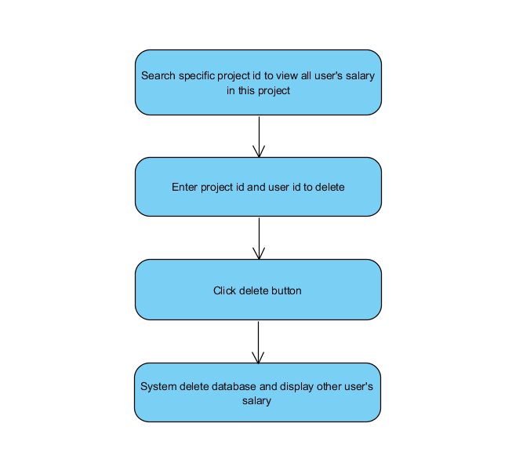

Basic flow of delete user’s salary in project

# Special Requirements

No Special Requirements.

# Preconditions

* Administrator have to login into application and access Manage Project view.

# Postconditions

* Project information displays in a table automatically.

# Extension Points

No Extension points.